Experiment 2 – Hexagonal Coverage, Cell Splitting and Handoff
Aim
To model a simplified hexagonal cellular network and study how cell radius affects coverage, estimated capacity and handoff.
Procedure
- Run the hexagonal-cell layout program and inspect the central cell and six neighbours.
- Run the cell-count and capacity calculation for different cell radii.
- Run the mobile-path program and note where the serving cell changes.
- Change the service area, cell radius or users-per-cell value and rerun.
Objective 1: Model adjacent hexagonal cell coverage areas.
MATLAB PROGRAM
clear; clc; close all;
R = 0.5;
axial = [0 0;1 0;1 -1;0 -1;-1 0;-1 1;0 1];
xc = sqrt(3)*R.*(axial(:,1)+axial(:,2)/2);
yc = 1.5*R.*axial(:,2);
ang = deg2rad(30:60:330);
figure; hold on;
for k=1:length(xc)
x = xc(k)+R*cos(ang); y = yc(k)+R*sin(ang);
patch(x,y,[0.8 0.9 1],'EdgeColor',[0.1 0.25 0.5]);
text(xc(k),yc(k),sprintf('Cell %d',k),'HorizontalAlignment','center');
end
axis equal; grid on; xlabel('Distance x (km)'); ylabel('Distance y (km)');
title('Seven Adjacent Hexagonal Cells'); hold off;

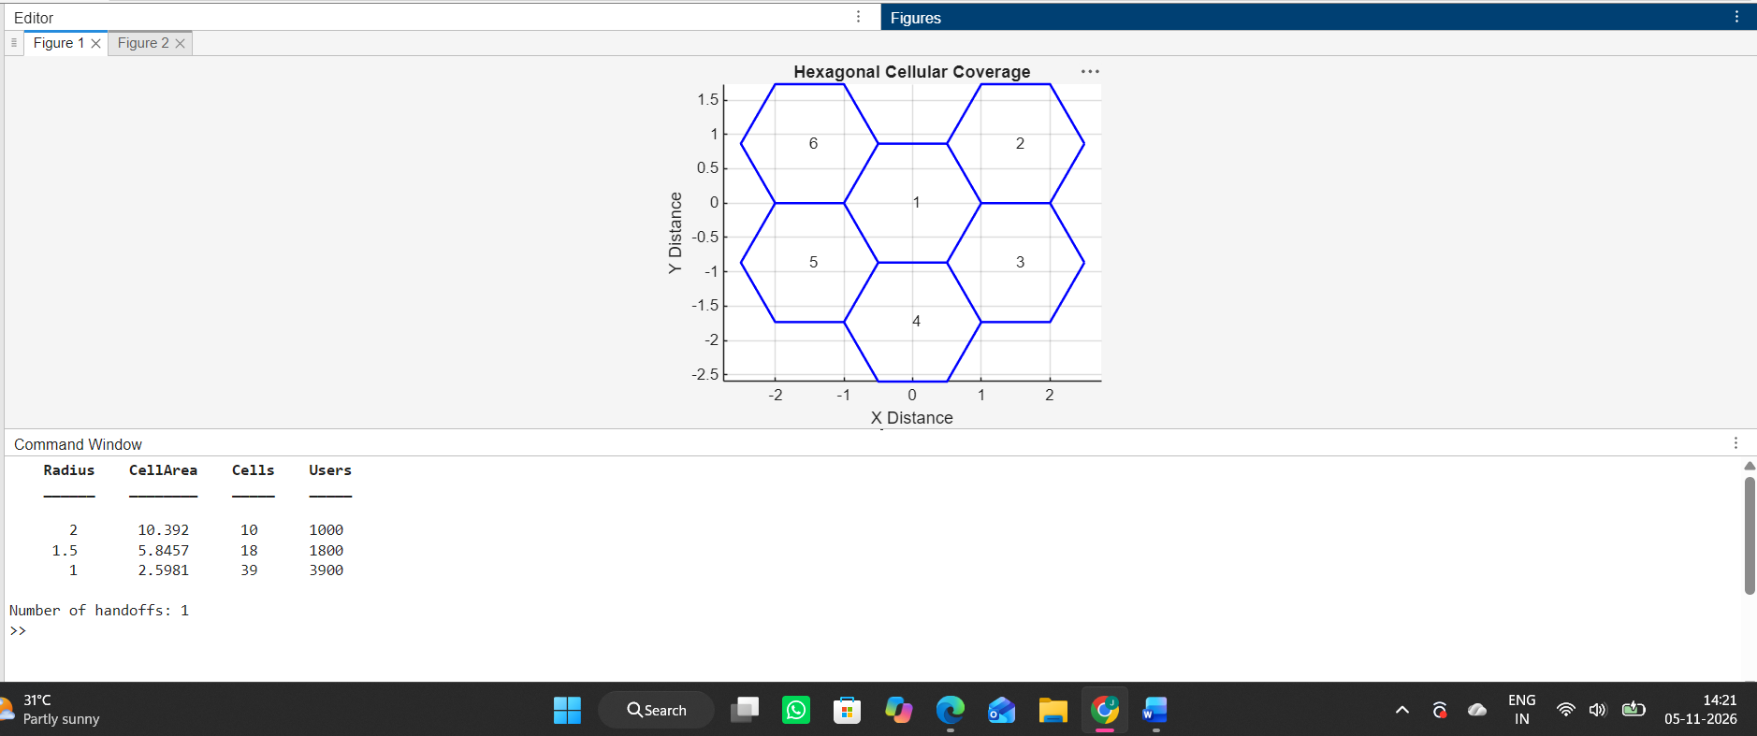

Objective 2: Estimate how cell radius affects the number of cells needed to cover a fixed area.
clear; clc; close all;
areaKm2 = 5;
radii = [1.0 0.75 0.5];
usersPerCell = 30;
cellArea = (3*sqrt(3)/2).*radii.^2;
cells = ceil(areaKm2./cellArea);
capacity = cells.*usersPerCell;
disp(table(radii',cellArea',cells',capacity', ...
'VariableNames',{'Radius_km','CellArea_km2','EstimatedCells','EstimatedUsers'}));
figure; bar(radii,capacity); grid on;
xlabel('Cell radius (km)'); ylabel('Illustrative user capacity');
title('Capacity Estimate versus Cell Radius');

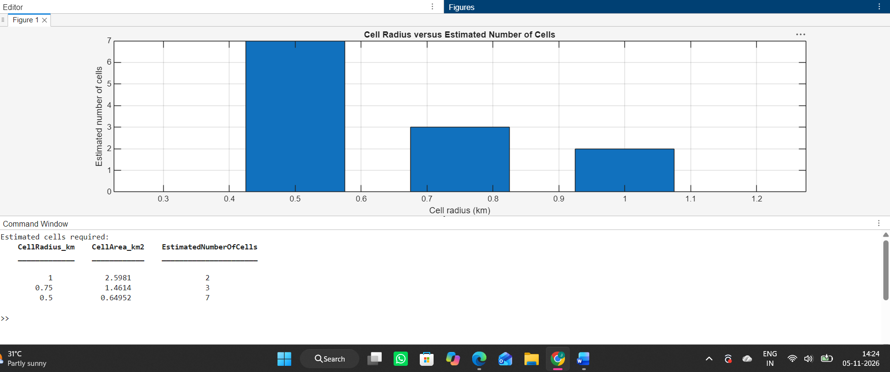

Objective 3: Compare estimated user capacity for different cell sizes under stated assumptions.
clear; clc; close all;
areaKm2 = 5;
radii = [1.0 0.75 0.5];
usersPerCell = 30;
cellArea = (3*sqrt(3)/2).*radii.^2;
cells = ceil(areaKm2./cellArea);
capacity = cells.*usersPerCell;
disp(table(radii',cellArea',cells',capacity', ...
'VariableNames',{'Radius_km','CellArea_km2','EstimatedCells','EstimatedUsers'}));
figure; bar(radii,capacity); grid on;
xlabel('Cell radius (km)'); ylabel('Illustrative user capacity');
title('Capacity Estimate versus Cell Radius');

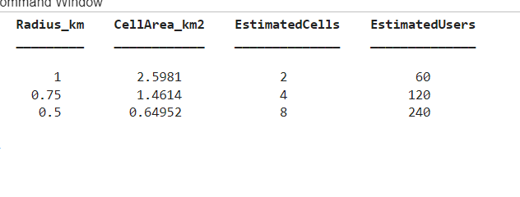
Objective 4: Simulate a mobile user moving between two cells and identify the handoff point using received signal strength.
clear; clc; close all;
x = -1:0.05:1; % Mobile moves across two cell centres
centres = [-0.5 0.5];
serving = zeros(size(x));
for k=1:length(x)
[~,serving(k)] = min(abs(x(k)-centres));
end
handoffIndex = find(diff(serving)~=0,1);
figure; stairs(x,serving,'LineWidth',2); grid on;
xlabel('Mobile position (km)'); ylabel('Serving cell number');
title('Simplified Handoff as Mobile Crosses Boundary');
if ~isempty(handoffIndex)
fprintf('Serving-cell transition near x = %.2f km\n',x(handoffIndex));
end
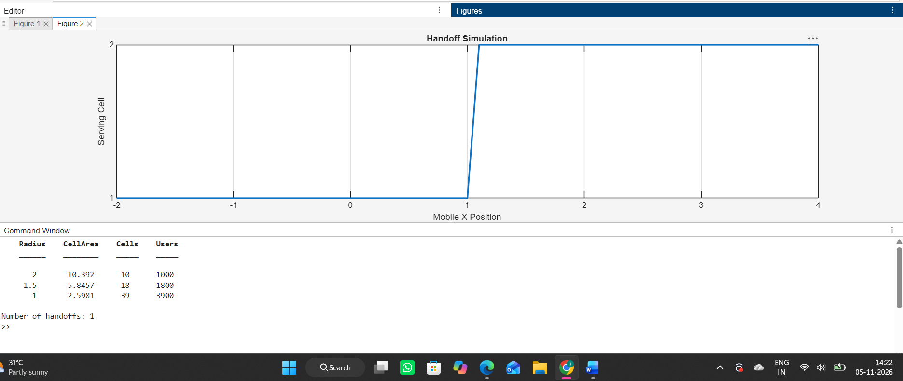
Result
Adjacent hexagonal cells were plotted. Smaller radii produce smaller cell areas and require more cells in the simplified area estimate. The nearest-cell model indicates a handoff when the closest cell centre changes.

